**School of Informatics & IT**

**Application Development Project (30%)**

**Database Application Development (45%)**

**(Web Application Design + Database Design)**

**AY 24/25 Oct Semester**

**Project 1 Report**

Contents

**Declaration of Originality** 3

DBAV Part 1: Database Design (45%) 6

Section A: Website Proposal (5%) 6

Section B: Interview Findings (3%) 7

Section C: Entities (3%) 8

Section D: Data Dictionary (4%) 9

Section E: ERD and Relationships (13%) 10

Section F: Normalisation (10%) 11

Section G: System Evaluation (7%) 12

ADEV Part 1: Web Application Design (30%) 13

Section H: User Interface Elements (5%) 13

Section I: Design Mock-up (10%) 13

Section J: Design Validation (10%) 14

Section K: Enhancements (5%) 14

**SCHOOL OF INFORMATICS & IT**

**Diploma in Information Technology**

**Project 1 Report**

Student Name (Matric Number) : Rosemol Saju

Tutorial Group : P05

Jenny LING (TP)

Tutor : Liew Pui Yee

Submission Date : 5th December 2024

**Declaration of Originality**

I am the originator of this work and I have appropriately acknowledged all other original sources used as my references for this work.

I understand that Plagiarism is the act of taking and using the whole or any part of another person’s work, including work generated by AI, and presenting it as my own.

I understand that Plagiarism is an academic offence

and if I am found to have committed or abetted the offence of plagiarism in relation to this submitted work, disciplinary action will be enforced.

**Declaration on the use of Generative AI tools for assignments**

|  |
| --- |
| Describe how you have used Generative AI tools such as ChatGPT or Dall.E- in your assignment.  Share the link to the conversations you had with the AI tool (i.e., the prompts you used and the responses you get from the AI tool).  **Please refer to this PDF on “How to share the conversations made with ChatGPT?”** |
| **Used grammerly for proper english structures.** |
| How do you indicate the reference?  The content generated by AI tools are not retrievable except by the user who generated them, so they are considered non-recoverable sources. Although non-recoverable data or quotations in APA Style papers are usually cited as personal communications, with ChatGPT-generated text there is no person communicating. Quoting text from ChatGPT chat is therefore more like sharing the output of an algorithm, with a reference list entry and the corresponding in-text citation.  According to the official APA Style site, ChatGPT references should be cited as:  E.g. OpenAI. (2024). *ChatGPT* (Feb 13 version) [Large language model].  <https://chat.openai.com/chat>  Note: The information in parentheses refers to the update or revision date of the model used. Refer to the release notes in the ChatGPT application. |

**Important Note:**

* Do not copy answers produced by the AI tool in totality as it is considered as plagiarism.
* Do not rely on any information produced by the AI tool blindly. You should always verify the answer with other sources. Do not assume that these answers provided by the AI tool are correct.
* To achieve quality outputs from the AI tool, you should provide good prompt that is clear and specific. Be precise and provide context. Avoid asking open-ended questions.

# DBAV Part 1: Database Design (45%)

## Section A: Website Proposal (5%)

Ensure that your website proposal covers the following points:

|  |  |
| --- | --- |
| Proposed online website idea | I am going to propose the idea the Campus Connect. It is an online platform that is specifically designed for IIT students to facilitate the sharing and exchange of resources and peer-to-peer services. It will allow students to post and borrow textbooks, notes, gadgets and other materials while at the same time offering a space for peer services like tutoring, project help and technical support. Students will be able to track borrowed items, manage lending histories, and communicate securely within the IIT community. This platform aims to promote a collaborative environment by ensuring that students can easily access the resources they need and offer help when possible, fostering an interconnected academic network. Ultimately, Campus Connect aims to enhance the efficiency of academic life at IIT by promoting resource-sharing, sustainability, and collaboration. |
| Purpose | The primary purpose of Campus Connect is to like to create a more cost-effective, collaborative and sustainable campus environment for all the IIT students. Textbooks, gadgets, and academic tools can be expensive and Campus Connect provides a way for students to access these resources at no cost by borrowing it from their peers. By creating a centralized platform for lending, borrowing and academic collaboration, the website will ease the financial burden on students while fostering a spirit of cooperation and academic support. Additionally, by offering services like tutoring and project help, the platform will serve as a one-stop solution for students seeking both academic resources and peer assistance. Campus Connect not only aims to save students money but also to strengthen the sense of community at IIT, making academic life more efficient and sustainable. |
| How it will enhance the experience of the IIT students | Campus Connect will greatly enhance the experience of IIT students in several keyways. One of the main benefits is the financial relief it gives. Many students face the challenge of purchasing expensive gadgets for projects, which are often only used for a short time. Through Campus Connect, students can borrow these items from others, significantly reducing the financial burden. The platform will also foster academic collaboration by helping students find tutors, share notes, and offer or seek assistance with projects and assignments. This peer-to-peer support system will promote teamwork and create a more interactive learning environment. Additionally, Campus Connect ensures security and trust by incorporating a rating and review system, allowing students to assess the reliability of those they are borrowing from or lending to, ensuring safe and transparent transactions. Features like due date alerts and resource availability notifications will also help students manage their time more effectively, keeping them organized and on top of borrowed items. Overall, Campus Connect will cultivate a more connected, efficient, and sustainable campus environment, helping students thrive both academically and socially, while reducing waste through resource sharing. |
| The need and demand for such an online website | The need and demand for the Campus Connect are mainly rooted in several key challenges faced by IIT students. One of the most significant challenges is the high cost of resources. IIT students often spend substantial amounts of money on electronic devices, creating a strong demand for a platform that allows them to borrow or share these resources. Preliminary surveys indicate that approximately 60-70% of students would prefer borrowing rather than buying textbooks and gadgets accordingly to the preliminary survey I did, reflecting a clear need for this kind of platform. Additionally, there is a gap in the availability of a centralized platform for academic collaboration. While informal networks exist between students, many often struggle to find study partners or seek tutoring services. Campus Connect will streamline this process by offering a space where students can easily find those to help them, share resources, and offer peer tutoring. This platform will also align with the growing interest in sustainability among IIT students. By encouraging the reuse of textbooks, gadgets and tools, it supports a more environmentally responsible approach to resource consumption. Campus Connect not only addresses these individual challenges but also promotes a more sustainable, efficient and collaborative campus culture. |

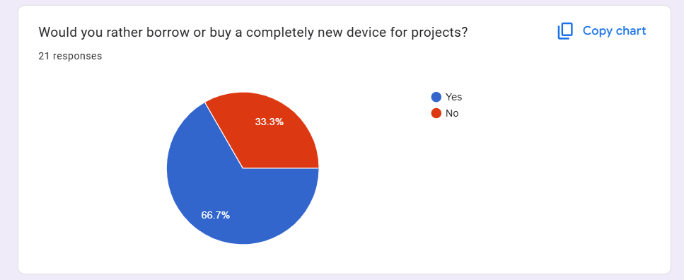

(Buying)

(Borrowing)

Figure 1 Survey Report on Borrowing and Buying Devices for Projects in IIT

## Section B: Interview Findings (3%)

Interview 5 (FIVE) IIT students to identify what kind of features they would want in the online website.

|  |  |
| --- | --- |
| **Student name & email** | **Desired feature** |
| Yu Shan  2400954j@student.tp.edu.sg | A searching function that allows students to filter resources (subject, book title, author) to make it easier to find the right materials for their courses. |
| Jerrisa Tan  2400977a@student.tp.edu.sg | A peer reviewing system for tutoring services, where students can rate and review the tutors they have interacted with. This will help in selecting the best tutoring help for subjects. |
| Alydia Koh  2404625b@student.tp.edu.sg | The ability to track borrowed items (books, gadgets) through notifications, ensuring that users remember due dates for return and can see the availability status of the resources in real-time. |
| Loke Si Xuan  2400542c@student.tp.edu.sg | An integrated chat system within the platform that allows students to connect instantly for discussing project work, clarifying doubts, or arranging resource exchanges (like lending books or gadgets). |
| Naw May Hazel  2403220c@student.tp.edu.sg | A feature that allows students to exchange or lend tech devices such as calculators, laptops, or even lab equipment, with an option to set a deposit fee or rental period. |

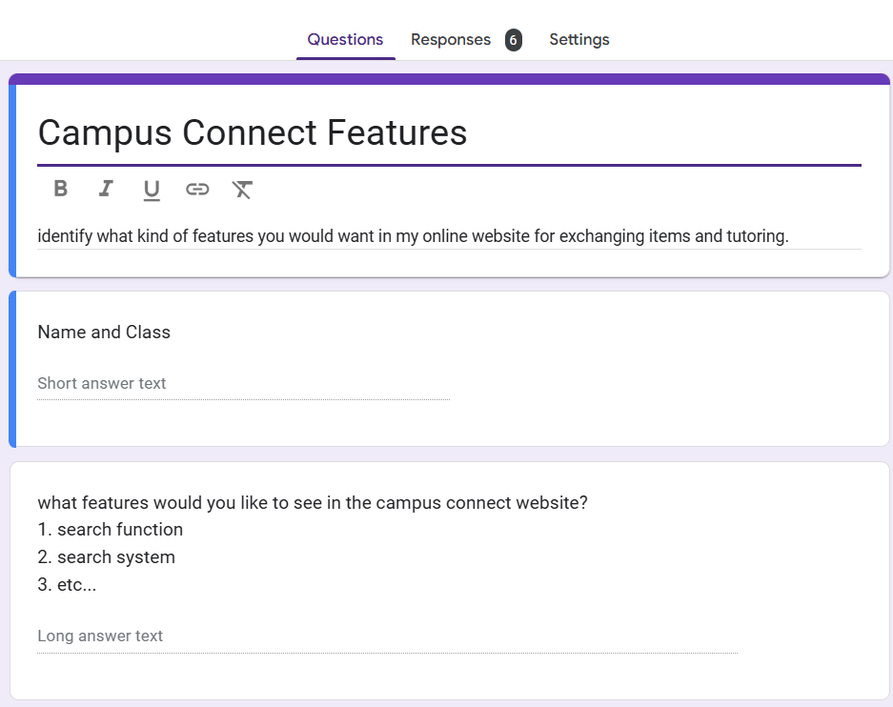

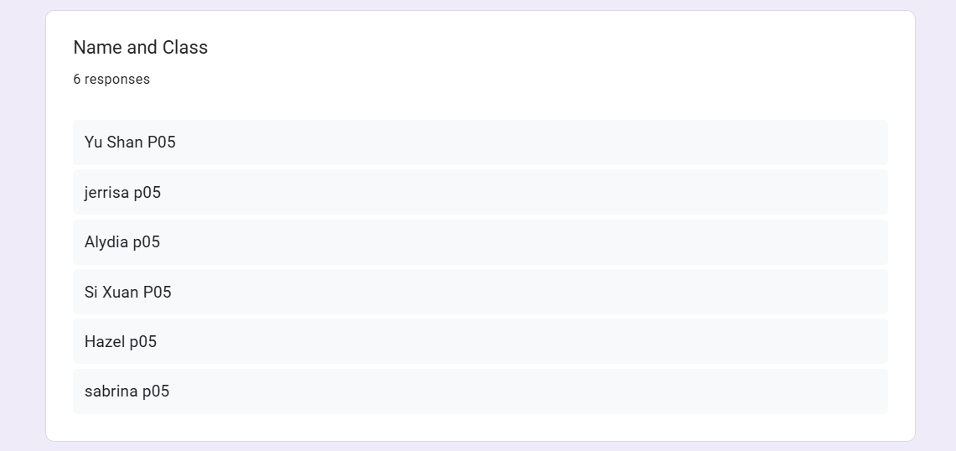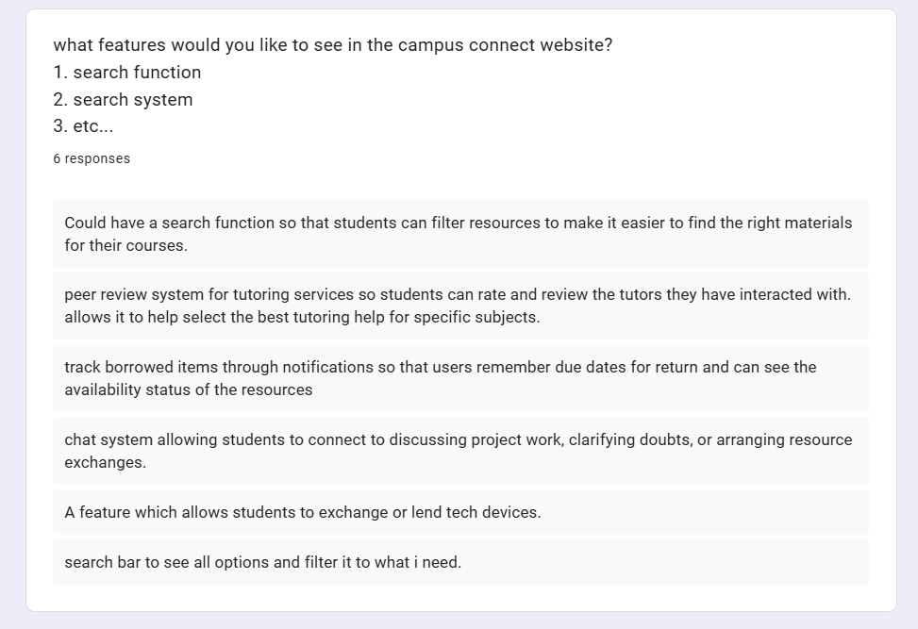

Figure 2 Survey Reports and Findings

Provide an insightful summary on the interview findings, listing all the features you would like to include in your proposed website:

Based on the interview findings, it reveals several key features that IIT students would like to see in the proposed **Campus Resource Exchange Platform**. Students really wanted an **advanced search and filter function** to easily locate academic resources based on criteria such as subject, book title, author, and edition. They also like requested a **peer review system for tutoring services**, allowing students to rate and review tutors to ensure quality and reliability. Additionally, there was a demand for **borrowed item tracking**, with notifications for due dates and real-time availability updates. Many students also highlighted the need for an **integrated chat system** to enable instant communication for project work, academic discussions, and resource exchanges but this might be hard to implement. Finally, students suggested a feature to **exchange or lend tech devices and specialized equipment**, such as laptops, calculators, and lab tools, with options for setting deposit fees or rental periods to ensure secure transactions. These features collectively aim to enhance collaboration, efficiency, and trust within the IIT community.

**Section C: Entities (3%)**

Identify 4 (FOUR) to 6 (SIX) entities that will be required. The entities identified must meet all the requirements of the online website proposed in Section A and have a clear purpose.

|  |  |
| --- | --- |
| **Entities** | **Reasoning for including it** |
| Student | This entity represents the students who will be using the platform. It will store their personal details like their name, student ID, email, and contact information. This is necessary for creating a student profile, authenticating users, and allowing them to interact with different features on the website, like borrowing or lending items and requesting tutoring services. |
| Academic Resource | This entity will hold information about study materials that students can borrow or lend. This can include devices and notes or other academic materials. It’s important for the website because it helps students find and manage the resources, they need for studying. This entity will include information like the title of the resource, the subject it belongs to, and whether it's available to borrow. |
| Tutor | The "Tutor" entity is for students who are offering tutoring services to others. It will store important details like the subjects the tutor can teach, their availability, tutoring rates, and reviews from other students. This entity is key because it helps connect students with tutors, making it easier for them to find academic help when needed. |
| Transaction | The "Transaction" entity will keep track of all the exchanges or borrowings of academic materials, equipment or tutoring sessions. It will record important information such as the resource or service being exchanged, the students involved, the dates and the status of the transaction (like whether it’s pending or completed). This entity ensures smooth management of borrowing and lending activities on the website. |
| Equipment | This entity is for managing the sharing of tech devices or tools that students might need for their studies, such as laptops, calculators, or lab equipment. It will store information about the type of equipment, its condition, and where it’s located. This is important because it helps students find and borrow the equipment they need to do well in their studies. |
| Review | The "Review" entity will store feedback from students about their experiences with tutors, academic resources, or borrowed equipment. It allows students to leave ratings and comments to help others make informed decisions. This is important for maintaining trust on the platform and ensuring the quality of the services and resources being shared. |

## Section D: Data Dictionary (4%)

For each entity listed in Section C, list at least 3 (THREE) relevant attributes. Clearly explain the rationale for your choice of attributes.

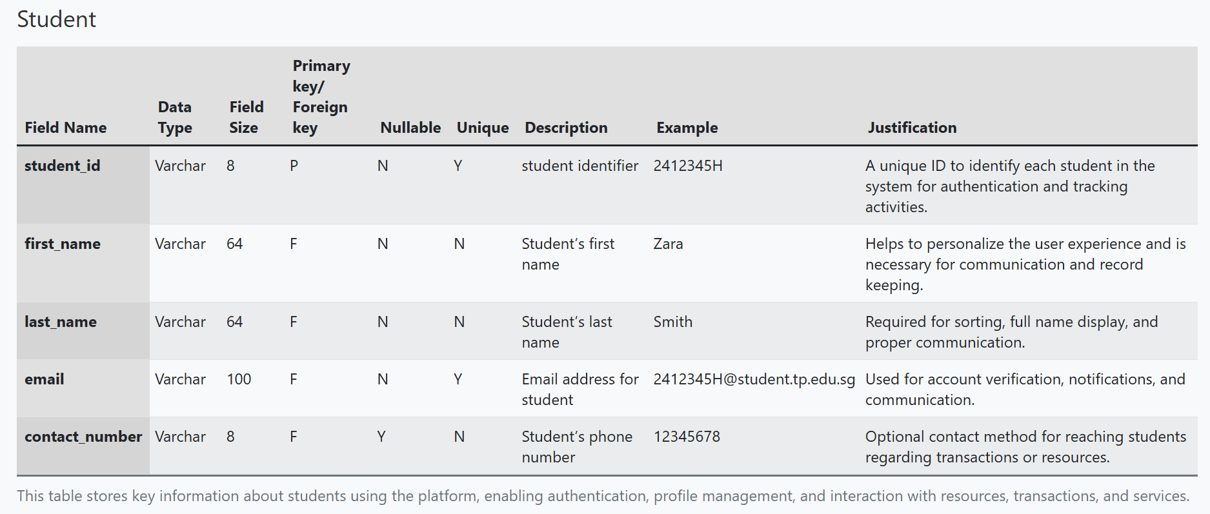

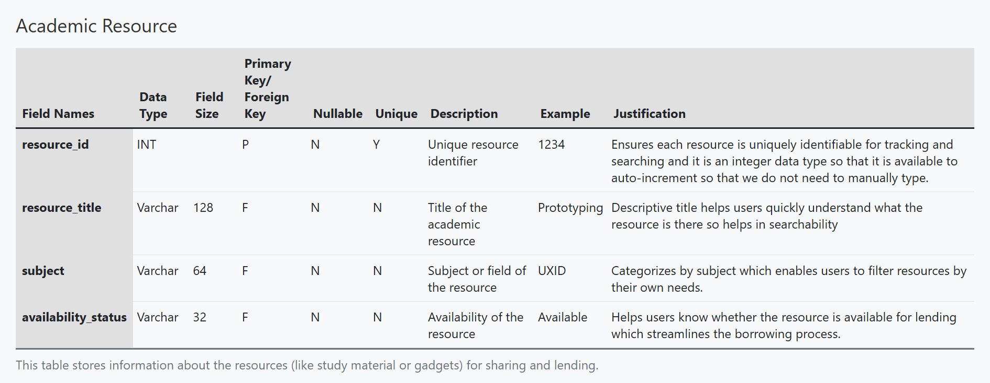

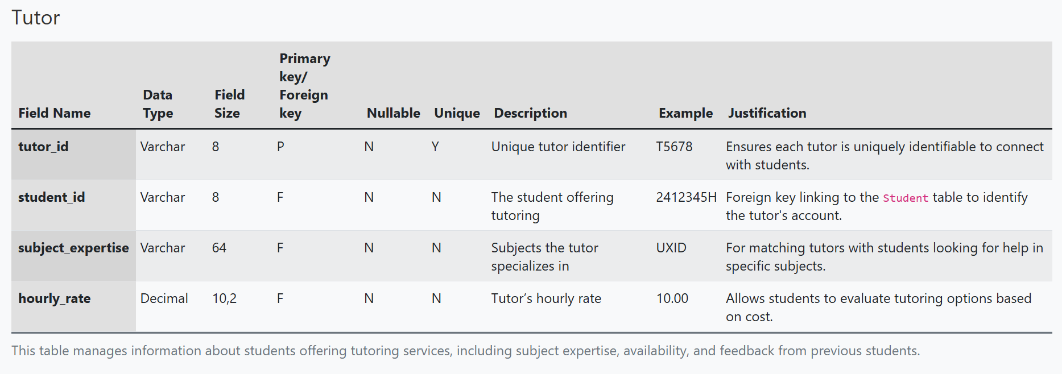

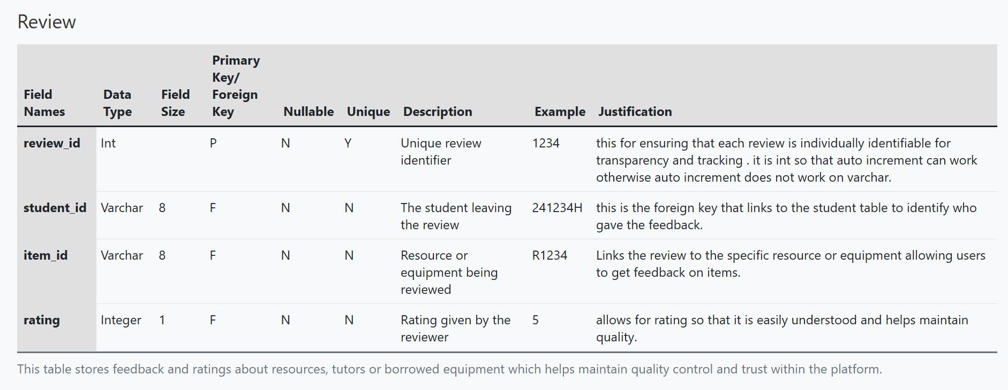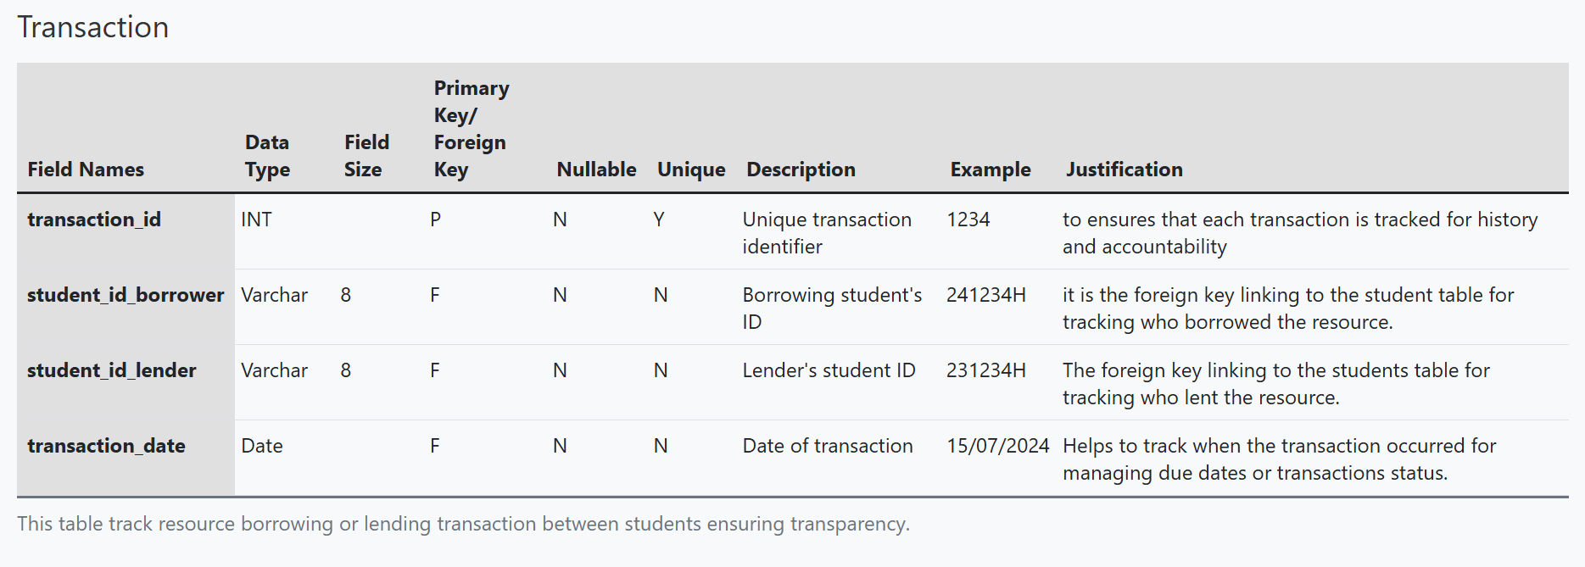

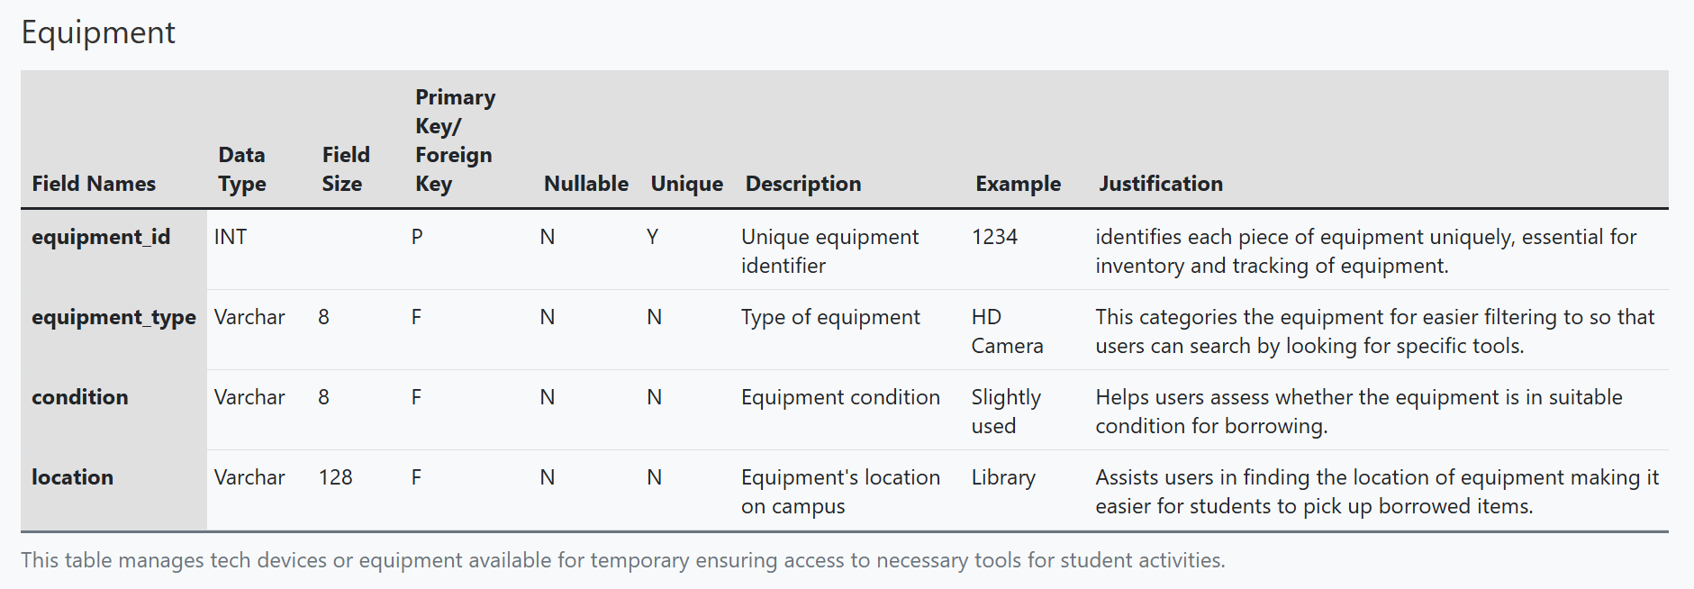

## Section E: ERD and Relationships (13%)

Paste a screenshot of your Entity-Relationship Diagram in this section.

Please make your screenshot image are sharp and clearly shown all the columns and their data type for each entity.

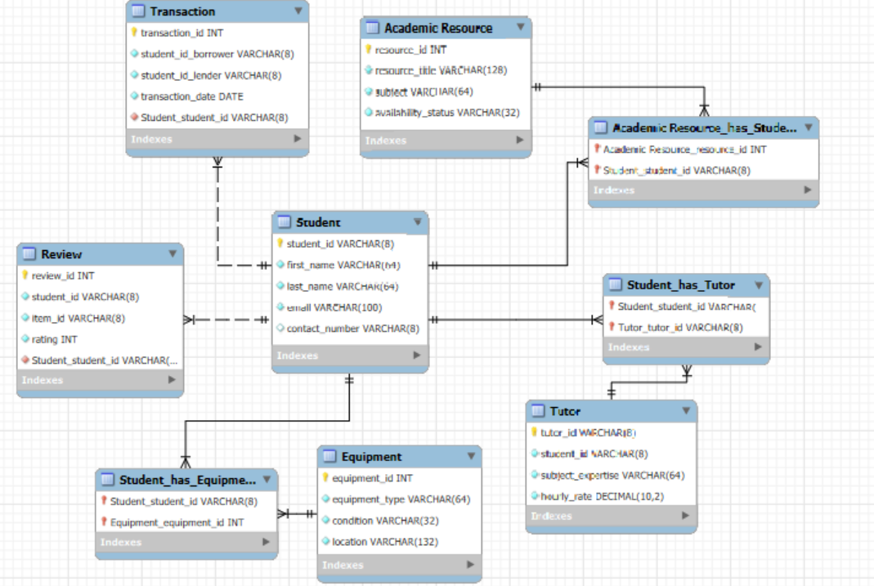

Figure 3 Entity-Relationship Diagram

For each relationship, identify the entities involved and clearly explain the rationale of the relationship in terms of meeting the requirements of the proposed online website in Task 1

|  |  |  |  |
| --- | --- | --- | --- |
| **Entity 1** | **Entity 2** | **Relationship** | **Justification** |
| Student | Transaction | One-to-Many | A student can make multiple transactions, but each transaction is linked to a specific student. |
| Student | Academic Resource | Many-to-Many | A student can borrow multiple resources, and each resource can be borrowed by many students. |
| |  | | --- | | Student |  |  | | --- | |  | | Tutor | Many-to-Many | A student can have multiple tutors, and a tutor can help multiple students. |
| Tutor | Subject | Many-to-Many | A tutor can teach multiple subjects, and a subject can have multiple tutors. |
| Student | Equipment | Many-to-Many | A student can borrow multiple types of equipment, and each piece of equipment can be lent to multiple students over time. |
| Student | Review | One-to-Many | A student can leave multiple reviews, but each review is associated with a specific student so that it allows feedback on tutors, resources, or borrowed items. |

**Section F: Normalisation (10%)**

Write a report of **no more than 300 words** on how you address the following issues:

1. How does your design prevent insertion anomalies?
2. How does your design prevent update anomalies?
3. How does your design prevent deletion anomalies?

Include significant examples to illustrate how your design addresses each anomaly.

**Insertion anomalies:**

Insertion anomalies occur when redundant or unnecessary data is inserted, causing inefficiencies in the database. To prevent this, the **Campus Connect** design ensures that each table stores only relevant and unique data for each entity. For example, the **Student** entity stores student-specific details such as name and ID, while transaction-related data (e.g., borrowed books, tutoring sessions) is handled separately by the **Transaction** table. This means that if a student has not participated in any transactions, no placeholder or redundant data is inserted into the database. This approach maintains data integrity and prevents unnecessary records, ensuring the system is efficient.

**Update anomalies:**

Update anomalies arise when updating one data point results in inconsistent information across multiple records. To avoid this, the design adheres to **Third Normal Form (3NF)**, ensuring each data point is stored once and linked via foreign keys. For example, when a student’s email address changes, it is updated only in the **Student** table. The **Transaction** table, which references the student, stores only the student ID as a foreign key, eliminating the need to update the email address in multiple places. This minimizes the risk of inconsistent data and simplifies updates, ensuring accuracy throughout the system.

**Deletion anomalies:**

Deletion anomalies occur when removing a record leads to the loss of related data. To address this, **referential integrity** is used through foreign keys. For example, deleting a student’s record does not affect their associated transactions, as the student’s ID is stored as a foreign key in the **Transaction** table. **Cascading deletes** are also employed to automatically remove related data when necessary, ensuring no standalone records are left behind and the database remains consistent.

By adhering to normalization principles and establishing strong entity relationships, **Campus Connect** effectively prevents **insertion, update, and deletion anomalies**, ensuring a clean, efficient and reliable system.

**Section G: System Evaluation (7%)**

**Write a report of no more than 200 words on:**

* At least 3 (THREE) limitations of your system. Provide justifications for these limitations, with examples relating to IIT where applicable.
* For any 2 (TWO) of the above limitations, provide suggestions on how to counter these limitations.

The proposed website design works well, but like it has a few limitations. First, scalability is a concern. As the number of students, transactions and resources grows at IIT, the system may slow down due to an overloaded database. To address this, database indexing and partitioning can be used to maintain speed. Regular performance checks and updates will also be necessary to ensure smooth operation.

Second, the website is not optimized for mobile devices, which is problematic since many IIT students access services via their phones. A mobile-friendly design would improve navigation. Using a responsive web design framework like Bootstrap or CSS media queries would ensure the website works well across different screen sizes.

Finally, security is a major concern, especially with sensitive student data. There is always the risk of data breaches. In order to protect personal information, encryption should be used to secure data both in storage and during transmission. Multi-factor authentication can also enhance security by ensuring only authorized users can access sensitive data. By addressing these limitations, the system can become faster, more accessible, and secure, providing IIT students with a better experience.

## ADEV Part 1: Web Application Design (30%)

## Section H: User Interface Elements (5%)

**Fill up the table below with no more than 150 words on each element's explanation:**

* Identify the FOUR (4) to SIX (6) key User Interface (UI) elements in terms of HTML that you will need to implement your database design.
* Explain each HTML element's purpose and use in the front-end web design.

**\*\* Add more rows if you need to.**

|  |  |
| --- | --- |
| **Element** | **Explain the purpose for use in the front-end web design** |
| <form> | The <form> element is like used to gather user input, like when a student registers, logs in, or selects a course. It’s the main way to send information to the server, like when you want to submit your login details or update your profile. Essentially, it's how users interact with the website to provide data, such as entering their name and password to log in. |
| <input> | This element is used inside forms to collect specific details from users. It can accept different types of data, like text, passwords, or emails. For example, students would use input fields to type their credentials or personal information. It's a flexible element that lets users provide different kinds of data in a structured way. |
| <select> | This one is used to create dropdown menus, so users can pick from a list of options. For instance, students might use it to select a course, department, or even their preferred equipment. This makes it easy to navigate the site and choose from options without cluttering the page. |
| <button> | This is what users click to take action. Whether it’s submitting a form, starting a search or logging in, buttons are important for interaction. For example, when a student clicks the “Login” button, the website knows to check their credentials. It’s how users tell the website what they want to do. |
| <table> | This one can be used to display data in a clean, organized format with rows and columns. It’s perfect for showing information like class schedules, lists of students, or available resources. Tables help make large amounts of information easy to read and compare, so students can quickly find what they need |
| <nav> | The nav is used for navigation links. It helps organize the menu so users can easily find different sections of the website, like their profile, courses, or available resources. This makes sure users can move around the site without getting lost, making everything easy to find. |

## Section I: Design Mock-up (10%)

**Fill up the tables below:**

* Design a mock-up of the proposed website's main page(s). The main page(s) must display at least 3 (THREE) of the key features of the online website. You can only create up to a maximum of 2 main pages.

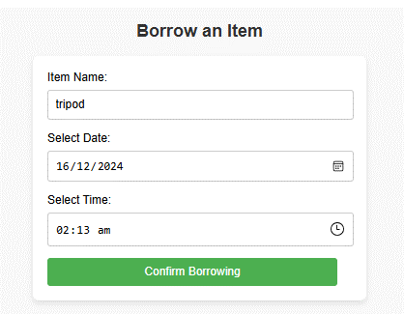

Form is below borrow items page unable to capture within one screenshot so I put here.

|  |
| --- |
| **Screenshot of main page(s) –** |
| <screenshots> |

|  |
| --- |
| **Code of main page(s) – Duplicate this table if you have more than 1 main page** |
| <HTML>  (*ENABLE EDITING OPTION TO SEE THIS FILE ALSO NEED TO DOUBLE CLICK TO ACCESS*) |
| <CSS> |

## Section J: Design Validation (10%)

**Fill up the table below with no more than 250 words.**

* Explain how your proposed design addresses functionality, ease of use and error handling.

|  |
| --- |
| **Explanation** |
| **Functionality:**  The design of the website includes key features like secure student login, easy course registration and a personalized dashboard. The login system ensures only registered students can access their accounts, keeping personal information safe. Students can browse available courses and easily sign up through the course registration feature, which is like connected to a live database to ensure up-to-date availability. The personalized dashboard shows important information, like upcoming assignments, grades and notifications, so students can stay organized and informed all in one place.  **Ease of Use:**  The website also has a clean, simple layout that’s easy to navigate. Important actions like logging in and registering for courses are clearly marked with large buttons that make the site straightforward to use. The top navigation bar is easy to follow, allowing students to quickly jump to key sections like their profile or course catalog. The design uses high contrast for easy reading and it is fully responsive, which means that it will work just as smoothly on mobile phones as on desktops.  **Error Handling:**  Furthermore, the design includes clear error messages to guide students if something goes wrong. For example, if login details are incorrect the system lets the student know right away with an easy-to-understand message. During course registration, students are warned if there are any schedule conflicts. The system also checks that all required fields are filled out before submission, preventing frustrating errors. If something goes wrong on the system's end, students will see a message explaining the issue. |

## Section K: Enhancements (5%)

**Fill up the tables below with no more than 150 words per enhancement:**

* Explain 2 (TWO) enhancements that you would need to do to the design in Task 9 to enrich the user experience for all IIT students.

|  |
| --- |
| **Enhancement 1 (**Mobile App Integration) |
| To make the **Campus Connect** experience an even better one for students, I would create a mobile app version of the platform. Since many IIT students are always on the go and on their phones, having a mobile app would allow them to access borrowed resources and tutoring sessions anytime, anywhere. The app would make it easier for students to check which books or equipment they have borrowed, schedule tutoring sessions, and get reminders about important due dates, like when a book needs to be returned. Push notifications would keep students updated about their resources and tutoring appointments, so they never miss an important deadline. By providing an app alongside the website, students will have a more flexible and convenient way to stay connected to the services they need. |

|  |
| --- |
| **Enhancement 2 (**AI-Based Personalized Recommendations**)** |
| Another great enhancement would be like use AI to offer more personalized recommendations for tutoring and borrowing. The system would learn from students' past tutoring sessions and borrowing history, then suggest tutors, resources, or equipment that might help with their current courses. For example, if a student frequently borrows books related to a certain subject, the system could recommend new books in the same area, or if a student had a good experience with a tutor, the AI could suggest similar tutors for future subjects. This would make it easier for students to find the help and resources they need, improving their academic experience. |

## References

1. <https://www.w3schools.com/html/> (to learn advanced HTML codes)
2. <https://www.youtube.com/watch?v=2O8pkybH6po> (to make form)
3. <https://www.rapidtables.com/tools/table-chart.html> (to make the tables in section D for data dictionary)
4. <https://girlswhocode.com/programs/code-at-home> (Previously learnt html and css from here so referenced back to make this website)
5. <https://docs.google.com/forms/u/0/> (to make the survey forms for getting feedback)